CpE 111 Homework Assignment #5 Maximum – 70pts

HW#5 is due at the beginning of class on Mar 14, 2007. You must always show or explain your work in a neat and orderly format. You are encouraged to discuss ideas with other students and consult references but your work must be your own.

1. Write the VHDL entity and architecture declaration for the module Gate_X defined by the truth table shown below. U and V are inputs and F is an output. (20pts)

U | V | F
0 | 0 | 1
0 | 1 | 1
1 | 0 | 1
1 | 1 | 0

2. Write the VHDL statement for Boolean function
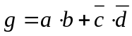
using concurrent operations. (10pts)

3. Construct the VHDL listing that describes the logic network shown below. Use VHDL vector statements. (20pts)

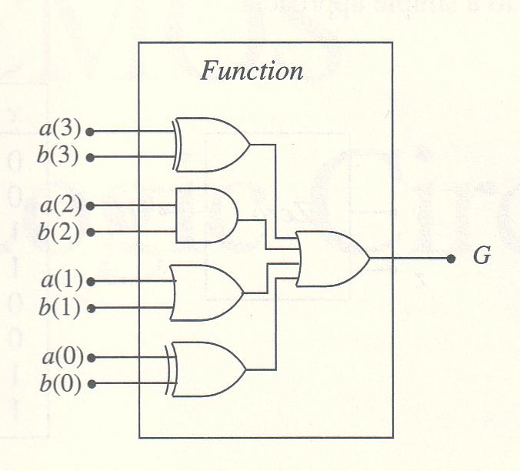

4. Construct the VHDL listing that describes the truth table shown below. Note that A,B and C are inputs and G is an output. Use the “when-else” statement. (20pts)

A | B | C | G
0 | 0 | 0 | 0
0 | 1 | 0 | 1
1 | 0 | 0 | 0
1 | 1 | 0 | 1
0 | 0 | 1 | 1
0 | 1 | 1 | 0
1 | 0 | 1 | 1
1 | 1 | 1 | 0

